Experimental Description

1. Experimental background

Here is the experiment in the paper " Chen J, Deng Y, Huang Z. HDCat: Effectively Identifying Hot Data in Large-Scale I/O Streams with Enhanced Temporal Locality[C]//International Conference on Algorithms and Architectures for Parallel Processing. Springer International Publishing, 2015: 120-133. "，The paper proposes and designs a hot data identification algorithm called HDCat by leveraging the combination of a D-bit counter and a recency bit.Real traces are employed to evaluate HDCat against two state-of-the-art schemes including a multi-hash function method and a two-level LRU approach. Experimental results demonstrate that HDCat can accurately capture the temporal locality of data access patterns and achieve a high hit ratio with low cache capacity and runtime overhead.

2. Setting up experimental environment

1) Trace

The trace in the paper is downloaded at <http://iotta.snia.org/tracetypes/3>,.You need to add a folder in the computer D drive TestData to store the trace. As shown below:

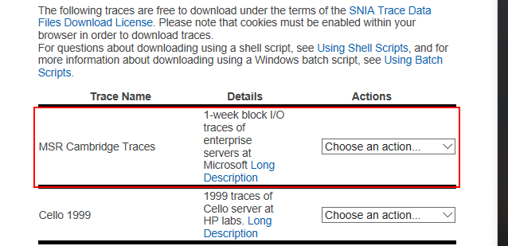

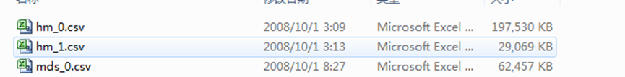

2) Operating environment

Program running environment need to install the database mySQL, and use VC or VS series compiler to compile the program. You need to add a database called cm in mySQL software, and in this database to establish the table rack1, rack2, rack3, three tables are designed as follows:

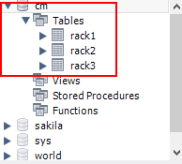

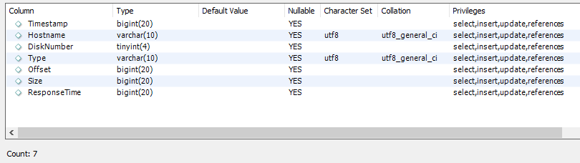

3）Experimental operation

Test program interface as follows, first load the data, and then use the various strategies to test.

